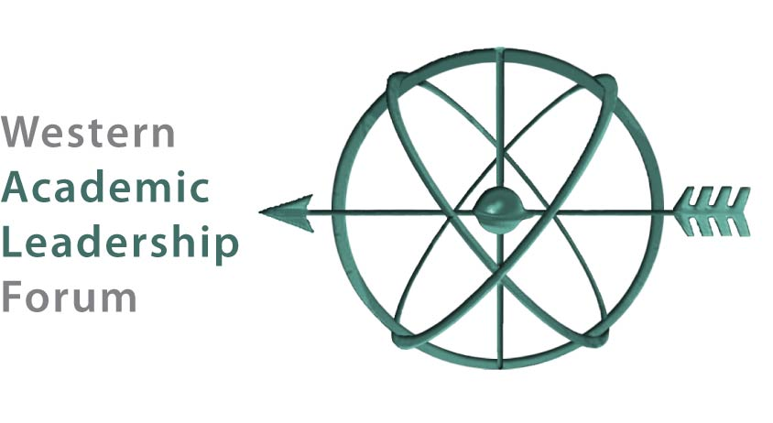

Colleagues’ Choice Award Competition

This year we will select one winner for the Colleagues’ Choice Award. The winning tool should demonstrate innovation, problem-solving capability, evidence of positive impact, and be replicable in the four-year sector. The winner will have an opportunity to present their tool on the final webinar of the Forum/Alliance Webinar Series on April 9, 2021. This is a great way to feature the work of your institution and staff! Use this form to enter the competition by telling us about a tool you have implemented successfully. Send the profile to Kay Hulstrom (khulstrom@wiche.edu) by February 14, 2021. You may submit more than one entry form, but there is a 2-page limit for each!
Title of Innovation:
Target Audience:
Goal(s):
Tool Category: Check all that apply. Policy Practice Program Service
Describe Key Issues Addressed and Hurdles Overcome:

Timeline from Idea to Implementation:
Resources Needed:

Evidence of Success:

Lessons Learned or Advice for Replication:

Web Address for More Information (if relevant):
Submitted by: Name, Affiliation, Email Address

